Al-Farabi Kazakh National University
Faculty of Law

Department of Customs, Financial and Environmental Law

Final Assessment Programme
Subject: ID 82902 Subsurface Use Law 6В04205
Education Programme in Law

Almaty 2025
The programme for the course's final examination was compiled by Senior Lecturer T. A. Toktybekov and was developed on the basis of the 6B04205 "Law" educational programme.
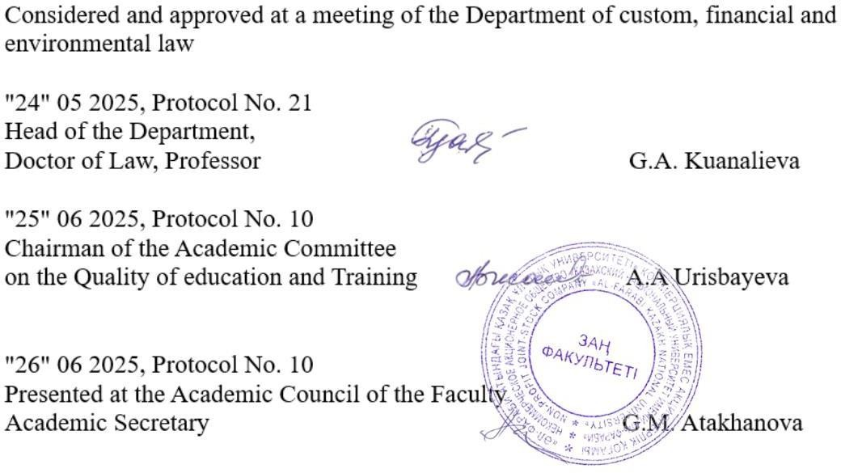

Introduction
The completion of the 6B04205 undergraduate education programme in 'Law' is concluded with a final examination, in accordance with the RK State General Compulsory Education Standard and academic policy. In accordance with the bachelor's degree study programmes and the academic work plan, only students who have completed the learning process for the subject and have earned the required number of credits are permitted to sit the final examination. The examination is held on the dates specified in the academic calendar and the academic work plan.
Students who receive an unsatisfactory grade are only permitted to resit the final examination for this period by paying a fee and retaking the course. An appeals procedure is available. A student who receives an unsatisfactory grade on the examination will be re-registered for the course by university order; if they score 25 points on the examination, the resit will be recorded as FX. Documents relating to health conditions submitted after the unsatisfactory grade has been awarded will not be considered.
Repeated examinations are not permitted for the purpose of improving grades. Examination questions are reviewed and approved. Due to the peculiarities of this academic year, admission to the university system is by means of a test. The test questions are composed of 200 items covering the topics of this curriculum, presented in three levels in the format prescribed by the guidelines, with one, two or three correct answers.

- Mining Law – 5 credits. Exam questions cover the following topics: Topic 1. Mining Law: definition, subject matter, methods, sources and historical development. Demonstrate an understanding of the content of the theory and legislation on applying new methodologies for activities in the field of subsurface use and state regulation to ensure legality.
Topic 2. Legal relations in the use of the subsoil: defining their concept, characteristics, participants, content, and the grounds for their arising, changing, and termination. Proving the peculiarities of the legal regulation of all institutions of the right to use the subsoil.
Topic 3. Elucidate the concept of ownership of the subsoil. Analyse this in comparison with the subject of land law. Determine the place and role of the right to exploit the subsoil in the Kazakhstani and international legal systems, highlighting the peculiarities of applying these norms in the state and non-state sectors of the economy.
Topic 4. Explaining and researching the implementation and execution of decisions on the granting of mineral resource exploitation rights. To refine the methods for analysing the application of subsoil use law norms, based on a critical assessment of the efficiency of various sectors of the Kazakh economy, in order to propose a comprehensive set of measures to improve their performance.
Topic 2. Outline the status of the bodies responsible for oversight in the field of subsurface use and protection. Explain the conditions for applying any provisions of the law on subsurface use.
Topic 3. Analysis of the specifics of legislative consolidation of norms in various practical situations. Classification of methods of state regulation and management. Analysis and determination of the specifics of state regulatory activity in the field of mineral resource use, as well as ensuring the effectiveness of the development of the country's mineral resource use institution.
Topic 4. Highlight the differences between the tax regime requirements for mineral users and other taxes. State regulation and administration to ensure the efficiency of the mineral exploitation institute's operations.

- Comparison of methods, application of state regulation and state management instruments. Topic 2. Determining the similarities and differences between state regulation and management and the grounds for applying these methods. Make recommendations for maintaining and ensuring legality in various sectors of subsurface resource utilisation. Develop measures to ensure compliance with legislation in the field of subsurface resource utilisation.
Topic 3. Analysis of issues concerning the fulfilment of international legal obligations in the field of mineral resource use. Explaining the causes of legal violations and their elimination.
Topic 4. Developing plans to improve the enforcement of legislation in various sectors of subsurface resource utilisation. Analysis of the legislation of the Republic of Kazakhstan and its conformity with international obligations and national interests, in order to formulate concrete proposals for improving and ensuring the safety of work in the field of subsoil use in Kazakhstan, based on the legal regulation of various areas of activity. Assessment of the legal re-evaluation practice in various fields of activity.
- Topic 3. A detailed exposition of the types of contracts in the subsoil use sector, with a classification of their differences. Justification of the need to fulfil international obligations, taking into account the national interests of Kazakhstan.
Topic 4. Evaluation of foreign countries' experience in ensuring the efficiency and safety of the subsoil use sector. Topic 13. Assess the feasibility of applying the positive experience of foreign countries to enhance the efficiency and safety of the Republic of Kazakhstan's subsurface use sector. Theoretically discuss the role and position of the national company in the subsurface use sector and its current achievements. Interpretation of the constitutional provisions on mining relations; definition of the principles of mining legislation; exposition of the structure of the Republic of Kazakhstan's Law on Subsoil and Subsoil Use; and identification of the differences in other laws governing mining relations.
Topic 15. Explanation of mining law relations. Explanation of the grounds for legal liability for breaches of legislation on the subsoil and its use. Analysis of the legal regulation of ancillary services to the use of the subsoil – land use, water use, other forms of special nature use, and the production of by-products. Providing commentary on the legal regulation of investment activity in the field of mineral resource utilisation. Explaining the grounds for legal liability for breaches of legislation on mineral resources and their utilisation. Provide a separate discussion of each of the following: criminal liability, administrative liability, and disciplinary liability, explaining their respective definitions.
Topic 16. Legal regulation of mineral resource use in the CIS and EAEU countries: an analysis compared with foreign legislation. Practically examine and analyse the legal support of mineral resource utilisation in foreign countries. Identify issues for improving the legislation governing relations in the field of mineral resource utilisation, and analyse its problems and prospects.

List of references:
1. Code of the Republic of Kazakhstan on Subsoil and Subsoil Use of 27 December 2017 No. 125-VI ZRK. http://adilet.zan.kz/rus/docs/K070000212.
2. The Environmental Code of the Republic of Kazakhstan of 9 January 2007 No. 212. Available as an electronic resource on the Adilet Unified Legal Information System website: http://adilet.zan.kz/rus/docs/K070000212.
3. The Land Code of the Republic of Kazakhstan of 20 June 2003 // Available as an electronic resource on the "Adilet" ISAP website: http://adilet.zan.kz/rus/docs/K030000442.
4. Nature protection legislation of the RK: A methodological textbook. A.I. Aldabergenova. - Kostanay, 2017. - 178 pp.

1. Nazhitdin Mukhitdinov Selected Works in 10 Volumes – 2nd edition, supplemented. Almaty: Nurai Print Service LLP, 2015. 2. Oil and Gas of Independent Kazakhstan. The Path of Transformation and Change Astana, 2017. – 212 p. 3. Oil and Gas of Independent Kazakhstan. Events. Facts. People Astana, 2017. – 352 p. 4. Oleynikova A. Ya., Stepenko V. E. Mining Law of Russia: Textbook. - Khabarovsk: TSU Publishing House, 2016. 5. Pevzner M.E. Mining Law, 5th edition, 2016, p. 384. 6. A.A. Esikeeva, Ә.K. Berdibaeva: Zherge құқықтарды memlekettik tirkeudi құқықтық retteu. Adistemelik қural. Almaty. – Kazakh University, 2015. – 122 p. 7. A.A. Esikeeva, Land rights issues and solutions in the Republic of Kazakhstan. Practical guide. Almaty. – Kazakh University, 2015. – 148 p.

Internet resources: The teaching materials – lecture notes on the right to exploit the subsoil, as well as the study-methodological materials required for homework, projects and independent study, are available on the page of your website at www.univer.kaznu.kz, in the POAK section.

Instructions for the examination:
1. The final assessment (exam) for the course 'Rights to Use of the Subsoil' for third-year, full-time students will be held as a test on the univer.kaznu.kz platform. All instructions have been uploaded to the univer.kaznu.kz homepage. The test-taking process is monitored by an automated proctoring system, or by a proctor or invigilator (if automated proctoring is not available). Proctoring technology (from the English word 'proctor' – to supervise an examination).
2. Important – the exam must be conducted in accordance with a pre-approved timetable, which should be communicated to lecturers and students in advance.
3. The final mark is automatically entered onto the mark sheet after the test has finished:
4. Marking time - up to 48 hours. The marking time may be extended when invigilating in online proctoring mode.
5. Test type - multiple choice, with 1, 2, or 3 correct answers.
6. The number of test questions in the Univer LMS is 40. One attempt is permitted. The test duration is 90 minutes.
7. Test questions in the Univer LMS are automatically generated.
8. The Univer IT test questions are automatically marked using the answer keys.
9. The student must be ready to enter the exam 30 minutes beforehand. This is a proctoring requirement.
10. The test results may be reviewed following the proctoring process. If a student breaches the testing regulations, their results will be voided.
11. The student can view additional guidelines and rules regarding the examination via links in the university system.

Assessment policy: Criterion-based assessment: evaluating learning outcomes against descriptors, verifying the development of competencies (the learning outcomes specified in the objectives) in mid-term assessments and examinations.
Summative assessment: assessing in-class activity and participation; evaluating completed assignments and independent work (project/case study/programme). A formula for calculating the final grade is provided.

RUBRICATOR FOR CRITERION-BASED ASSESSMENT OF FINAL CONTROL
Discipline: Environmental safety in maritime and energy law
Form: Standard (oral)
Platform: IS Univer

Question 1. Maximum score – 33.
№ | Points  Criteria | Descriptors
№ | Points  Criteria | «Excellent» – 28–33 points | «Good» | «Saticfaction» | «Unsatisfaction»
№ | Points  Criteria | 28–33 points | 20-27 point | 14-19 points | 7-13 points | 0-6 points
1 | Understanding the  general | Demonstrates a clear understanding of the | Identifies and  analyzes the | Correctly interprets and applies relevant articles of the Water Code and related legislation to practical or hypothetical cases. | Compares domestic and  international water law | Demonstrates logical, structured,
1 | characteristics and | concept, subject, and | main problems |  | systems; evaluates | and reasoned oral
1 | types of problems | principles of water law; | of water use and |  | strengths and weaknesses | answers; uses legal
1 | in Alternative energy | explains key legal | protection in |  | of different legal | terminology
1 | Law | definitions and categories. | Kazakhstan and abroad; provides |  | approaches. | appropriately and answers examiner’s
1 |  |  | examples and |  |  | questions clearly.
1 |  |  | possible
1 |  |  | solutions.

 | Knowledge of current issues and problems | dentifies and explains key legal, environmental, and institutional problems in water resource management and protection; | Demonstrates knowledge of modern challenges such as water scarcity, transboundary water disputes, pollution, and climate impacts;. | nalyzes causes and possible legal solutions to the identified problems; | Uses correct legal terminology and logical reasoning in responses. | Demonstrates knowledge of modern challenges such as water scarcity, transboundary water disputes, pollution, and climate impacts;.
 | The student formulates well- reasoned policy proposals or practical recommendations related to improving water legislation and governance. | Suggests concrete and realistic measures to improve water law and management; | Demonstrates understanding of state policy mechanisms in water regulation; | Uses legal and analytical justification for proposals; | Recommendations are specific, feasible, and logically argued. | Demonstrates knowledge of modern challenges such as water scarcity, transboundary water disputes, pollution, and climate impacts;.

2 | Question 2. Maximum score – 33.
 | Points  Criteria | Descriptors
 | Points  Criteria | «Excellent» – 28–33 points | «Good» | «Saticfaction» | «Unsatisfaction»
 | Points  Criteria | 28–33 points | 20-27 point | 14-19 points | 7-13 points | 0-6 points
 | Application of practice and use of theoretical knowledge | The student demonstrates the ability to apply theoretical knowledge of water law to practical situations, analyze real-life cases, and propose legally justified solutions based on national and international legal norms | Correctly applies theoretical concepts of water law to practical and problem- based questions; | Refers to specific articles of the Water Code of the Republic of Kazakhstan and other normative acts; | Demonstrates the ability to connect theory with practice, drawing conclusions and suggesting appropriate legal measures; | Provides coherent, structured, and evidence- based answers during the oral exam.
 | Question 3. Maximum score – 34.
 | Points  Criteria | Descriptors
 | Points  Criteria | «Excellent» – 28–34 points | «Good» | «Saticfaction» | «Unsatisfaction»
3 | Points  Criteria | 28–34 points | 20-27 point | 14-19 points | 7-13 points | 0-6 points
 | Problem solving and practical recommendations | The student demonstrates the ability to identify legal and environmental problems in the field of water law and propose practical, well- reasoned  recommendations for | Clearly identifies and explains specific problems in water law or water management practice; | Provides logical, evidence-based solutions supported by relevant legislation, case studies, or international experience; | Demonstrates critical and analytical thinking when evaluating the effectiveness of current legal norms | Communicates answers coherently, using correct legal terminology and showing a comprehensive understanding of the issue.

their resolution based on theoretical knowledge
and legal norms..

Letter Grade | Numerical Equivalent | Scores (Percentage Indicator)) | Grade according to the traditional system
А | 4,0 | 95-100 | Exelent
А- | 3,67 | 90-94 | Exelent
В+ | 3,33 | 85-89 | Good
В | 3,0 | 80-84 | Good
В- | 2,67 | 75-79 | Good
С+ | 2,33 | 70-74 | Good
С | 2,0 | 65-69 | Satisfactory
С- | 1,67 | 60-64 | Satisfactory
D+ | 1,33 | 55-59 | Satisfactory
D- | 1,0 | 50-54 | Satisfactory
FX | 0,5 | 25-49 | Unsatisfactory
F | 0 | 0-24 | Unsatisfactory

